# Geek Registration System – GRS

## Application Architecture

The application architecture follows Dependency Invasion Principle. Using clean architecture principle, the business logic and application model are at the center of the application. Instead business logic depend on the data access or other infrastructure concerns, this dependency is inverted: Infrastructure and Implementation details depend on the Application Core. This is achieved by defining abstractions. Or Interfaces, in the Application Core, which are then implemented by types defined in the Infrastructure layer. The following figure shows the overall architecture:

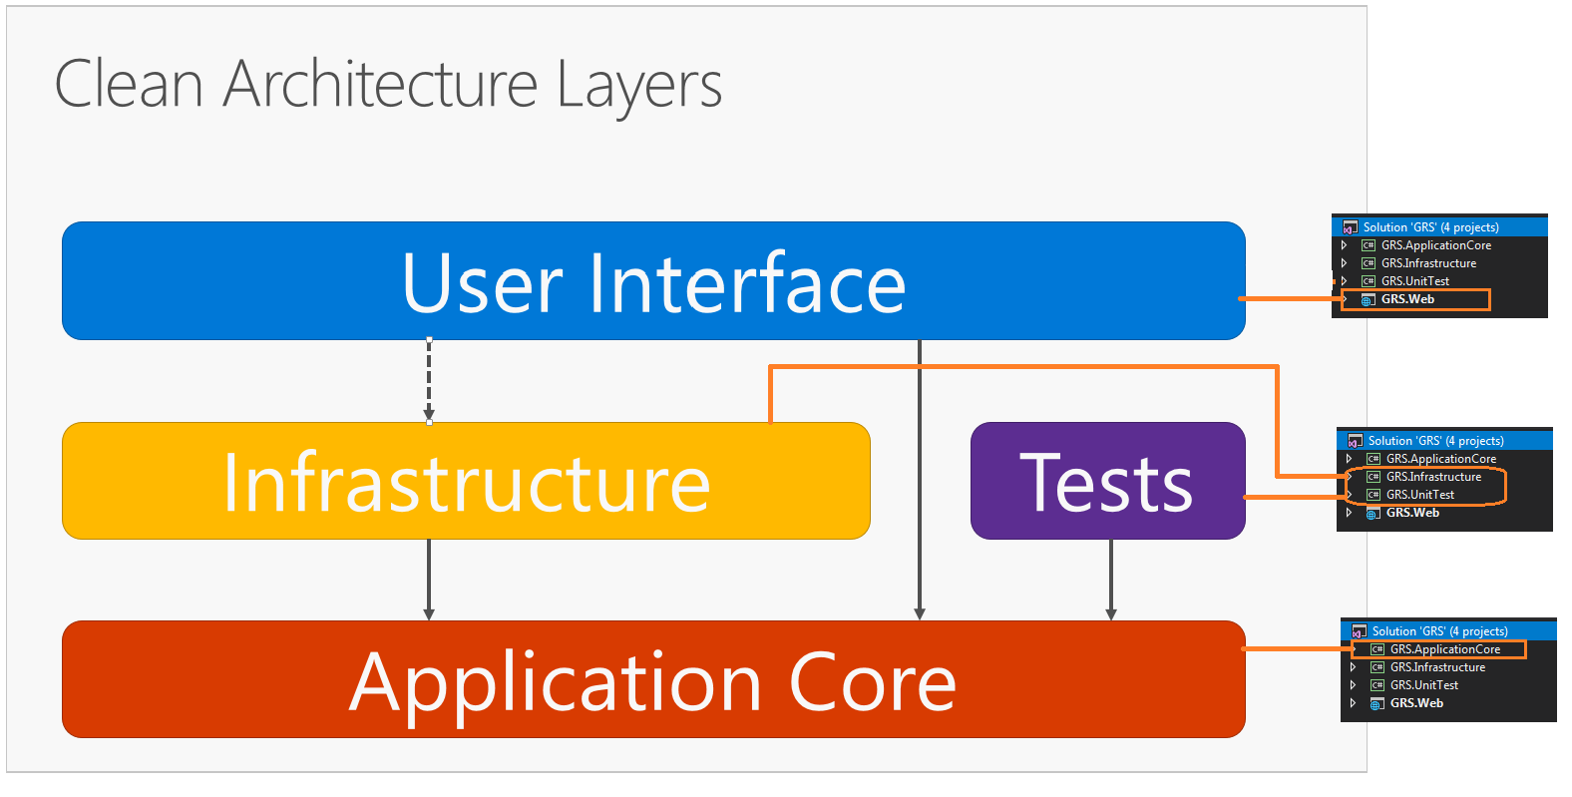

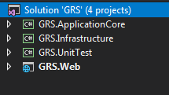

## Tools and Technologies

Here are the list of main tools and frameworks but not limited to these are used to develop the application.

* ASP.NET MVC Core for UI
* ASP.NET Core DI Service
* Entity Framework Core
* Bootstrap
* NUnit and MOQ for unit testing

## Application Database

There are two databases for the application of is to store the application data and the other is for storing the user and identity information. Database backups “GRS.bak” and “GRS.Identity.bak” are provided for easy restores.

“GRS” Application Database Tables:

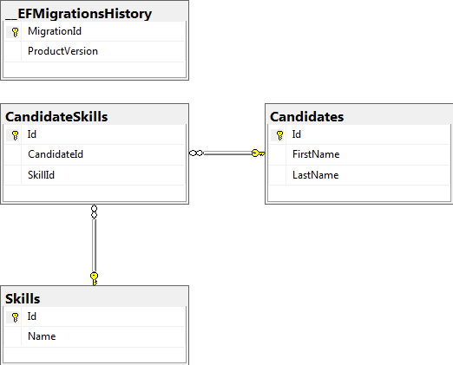

“GRS.Identity” database tables:

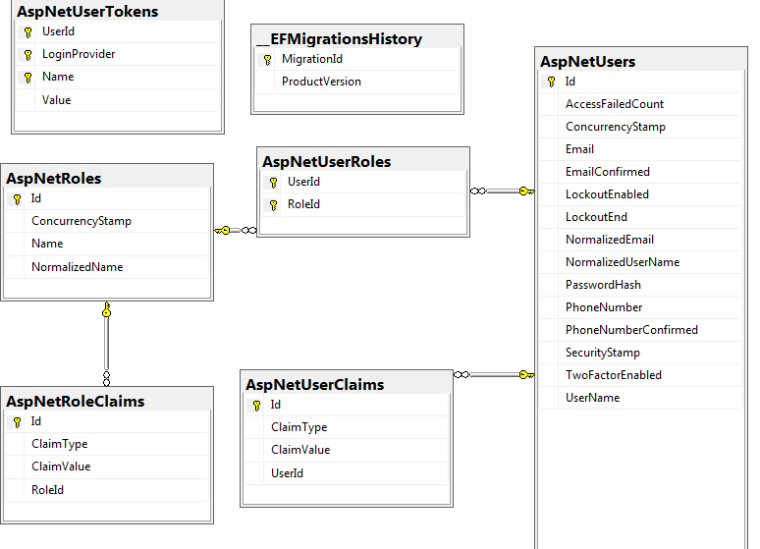

## Application Unit Test Cases

Number of unit test cases are developed to test the functioning of the application

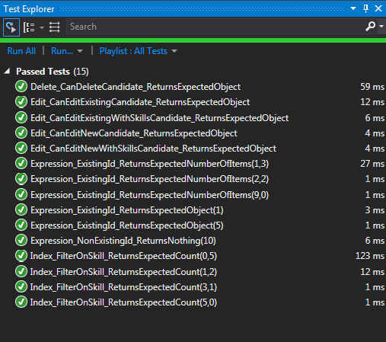

Please follow this link <https://github.com/nunit/docs/wiki/Adapter-Installation> for configuring Visual Studio to run NUnit test cases.

## Application User Interface

## Candidate List View

The following is the application login screen. For simplicity ‘admin’ user will be created when MVC application start.

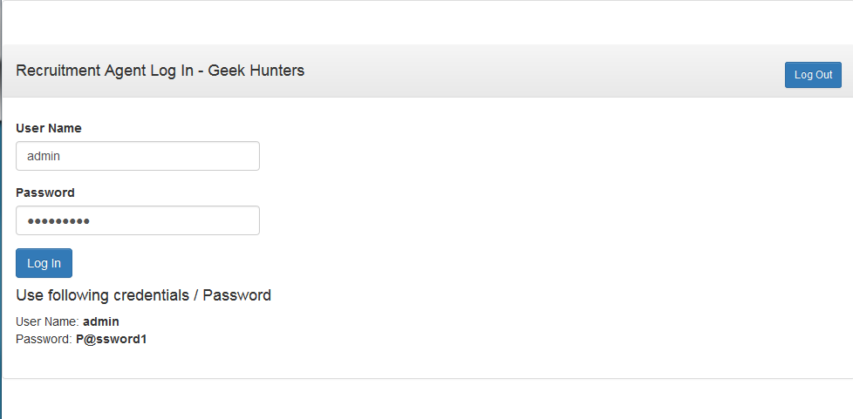

## Candidate List View

The application provides a list view of the candidates where recruitment agent view all the candidates and filter the candidates by skill/technology.

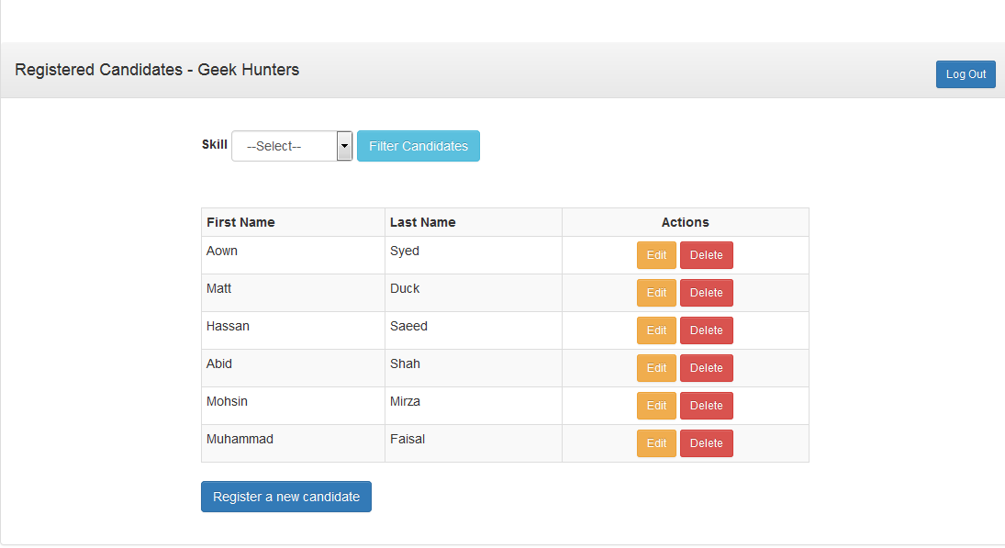

## Register Or Update Existing Candidate Information

From the list view of the application agent can click “Register a new candidate” to define a new candidate or click “Edit” to update existing candidate information.

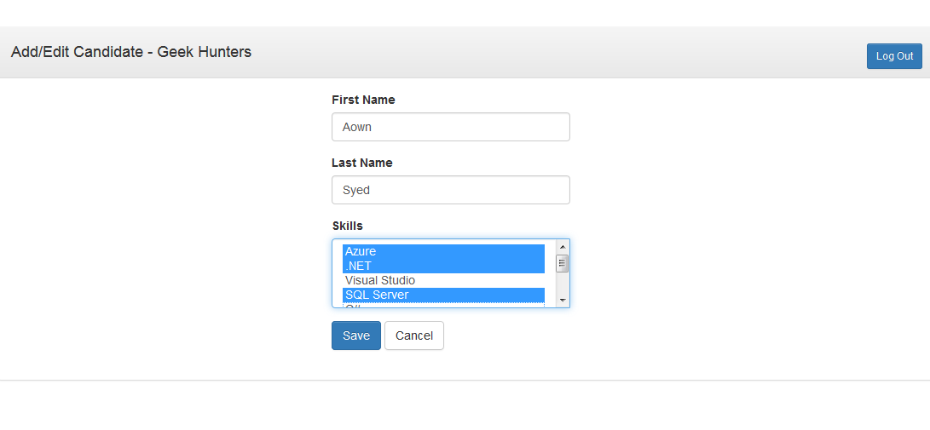

## Delete Candidate information

From the List view of the application user can delete candidate information.

## Filter Candidates

User can use filter button to search candidates based on their skill/technology.

